Geometry: Unit 12, Lesson 7
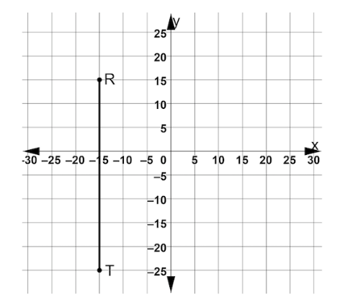
- Line segment $TR$ is shown on the coordinate plane. Point $T$ is located at $(-15,-25)$ and point $R$ is located at $(-15,15)$. What is the length of $\overline{TR}$?

$$TR=40 units$$

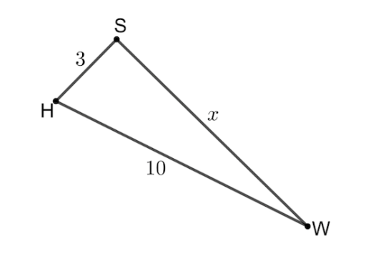
- Right triangle $WHS$ is shown, where $\overline{HS}⊥\overline{WS}, HS=3, WH=10,$ and $WS=x.$ Write and equation that can be used to solve for $x.$

$$3^{2}= {10}^{2}+ x^{2}$$

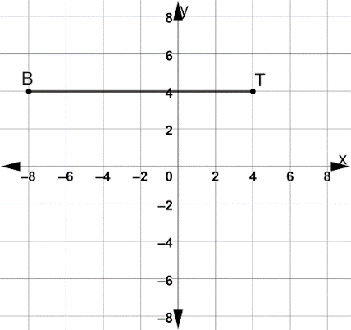
- Line segment $BT$ is shown on the coordinate plane. Point $B$ is located at $(-8,4)$ and point $T$ is located at $(4,4)$. What is the length of $\overline{BT}$?

$$BT=12 units$$

